Introduction to "Research & Development Department Academic Activity Subsidy/Reward" System
Table of Contents
1. Logging in …………………………………………….……………………..….1

2. Creating new applications ……………………………………………..……..2
2.1 Create new application …………………………...……………..………………...2
2.2 Policy reference for academic activities ……………………………...…………...2
2.3 Application form for activity subsidies …………………………………………...3
A. New Instructor's Research …………………………………………………….3
B. Convention of International Conference and Seminar ……..…..……………..4
C. Arts Exhibition and Performance …………………………..………………….5
D. Academic Thesis Publication …………………………………………………..6
E. Academic Book Publication ……………………………………….…………...7
F. Page Charge for Original Thesis Publication …………………………...……...8
G. Overseas Thesis Publication in International Conferences ……………..……..9
H. Improved Academic Research (Team) ……..………………………………...10
I. Improved Academic Research (Individual) …………..……………………….11
2.4 Fill in the application and upload attachments ………………...………..……….12
2.5 Confirming application status and printing the application form …………….….12

3. Case list ………………………………………………………………………....13
3.1 Case status ……………………………...……………………………….……….13
3.2 Edit content ……………………………...……………………………………….13
3.3 Replace attachment ……………………………...……………………………….13
3.4 Upload progress report …………………………...………………………...….13

4. Log off ……………………………………………………………………..…....14

5. Contact information ……………………………………………………..…....14

Handling Unit: Division of Academic Research Promotion and Coordination, Research & Development Department, National Taiwan Normal University
Date prepared: July 16, 2012
1. Logging in
1.1 Please log in to the NTNU Information Portal by inputting "Account No." and "Password."
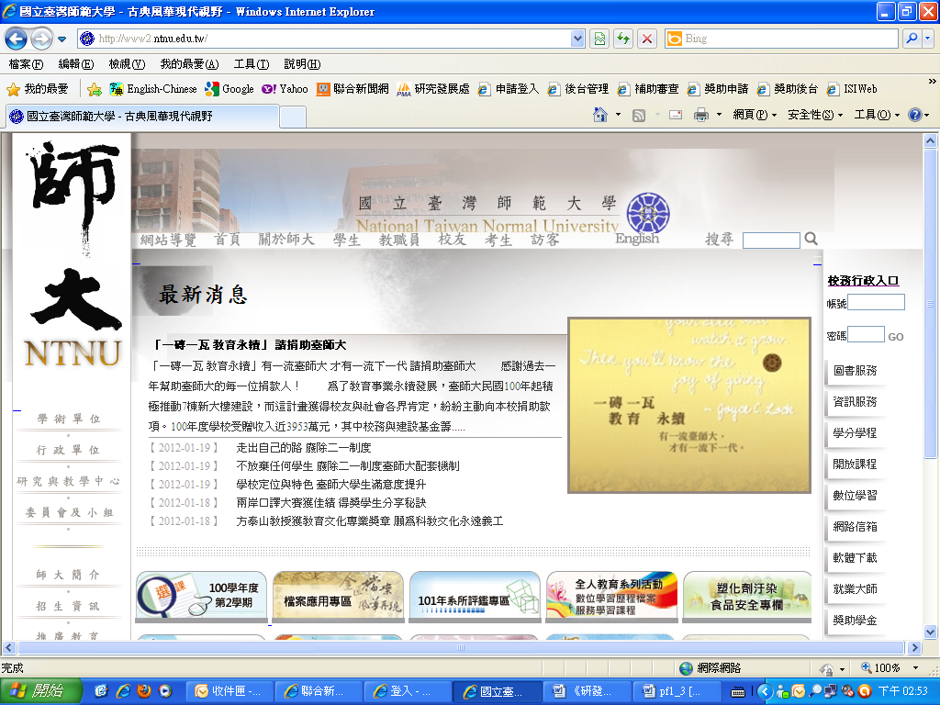

1.2 Click on "Applications" → "Application System of Research & Development Department."
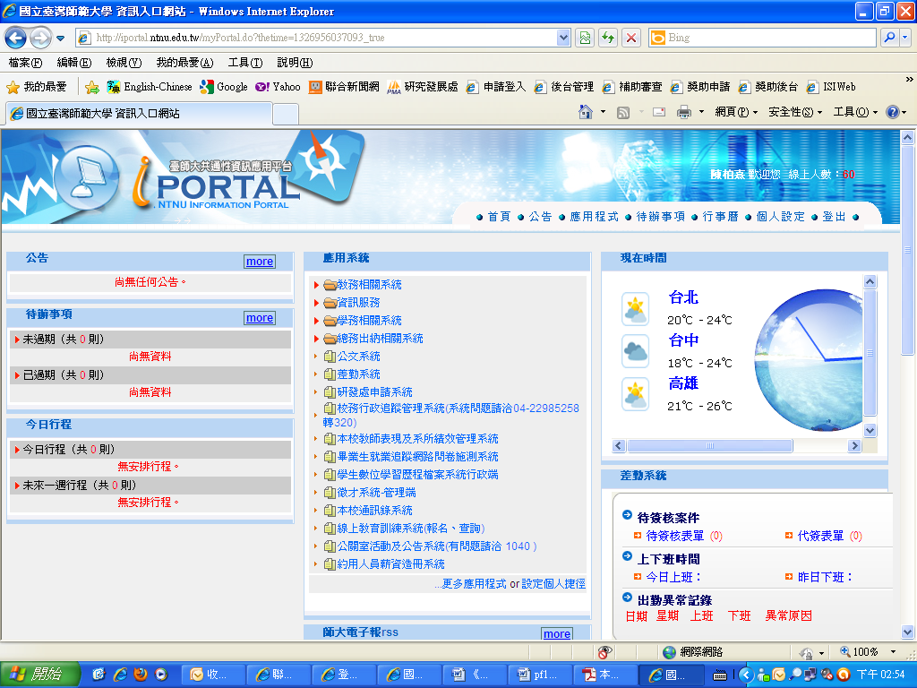

2. Creating new applications
2.1 Create a new application: click on the activity to be subsidized/rewarded to bring up the application form.
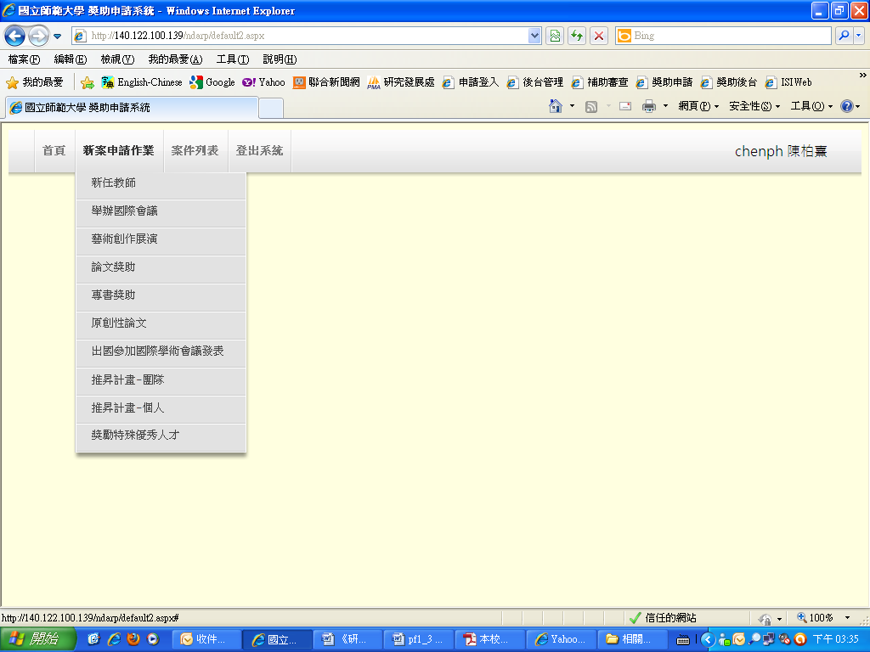

2.2 Policy reference for academic activities
Academic activity |  | Policy reference
A | New instructor | National Taiwan Normal University Subsidy Policy for New Instructor's Research
B | International conference | National Taiwan Normal University Subsidy Policy for Convention of International Conference and Seminar
C | Exhibitions & performance | National Taiwan Normal University Subsidy Policy for Arts Exhibition and Performance
D | Thesis publication | National Taiwan Normal University Subsidy Policy for Thesis and Book Publication
E | Book publication
F | Original Thesis Publication | National Taiwan Normal University Subsidy Policy for Original Thesis Publication
G | Overseas thesis publication | National Taiwan Normal University Subsidy Policy for Instructors' and Researchers' Overseas Thesis Publication
H | Improved Research - Team | National Taiwan Normal University Subsidy for Improved Academic Research Plan
I | Improved Research - Individual
(File path: Research & Development Home Page → Policies → Division of Academic Research Promotion and Coordination)

2.3 Application form for activity subsidies

A. New Instructor's Research (Two terms per year: Mar./Sep.)
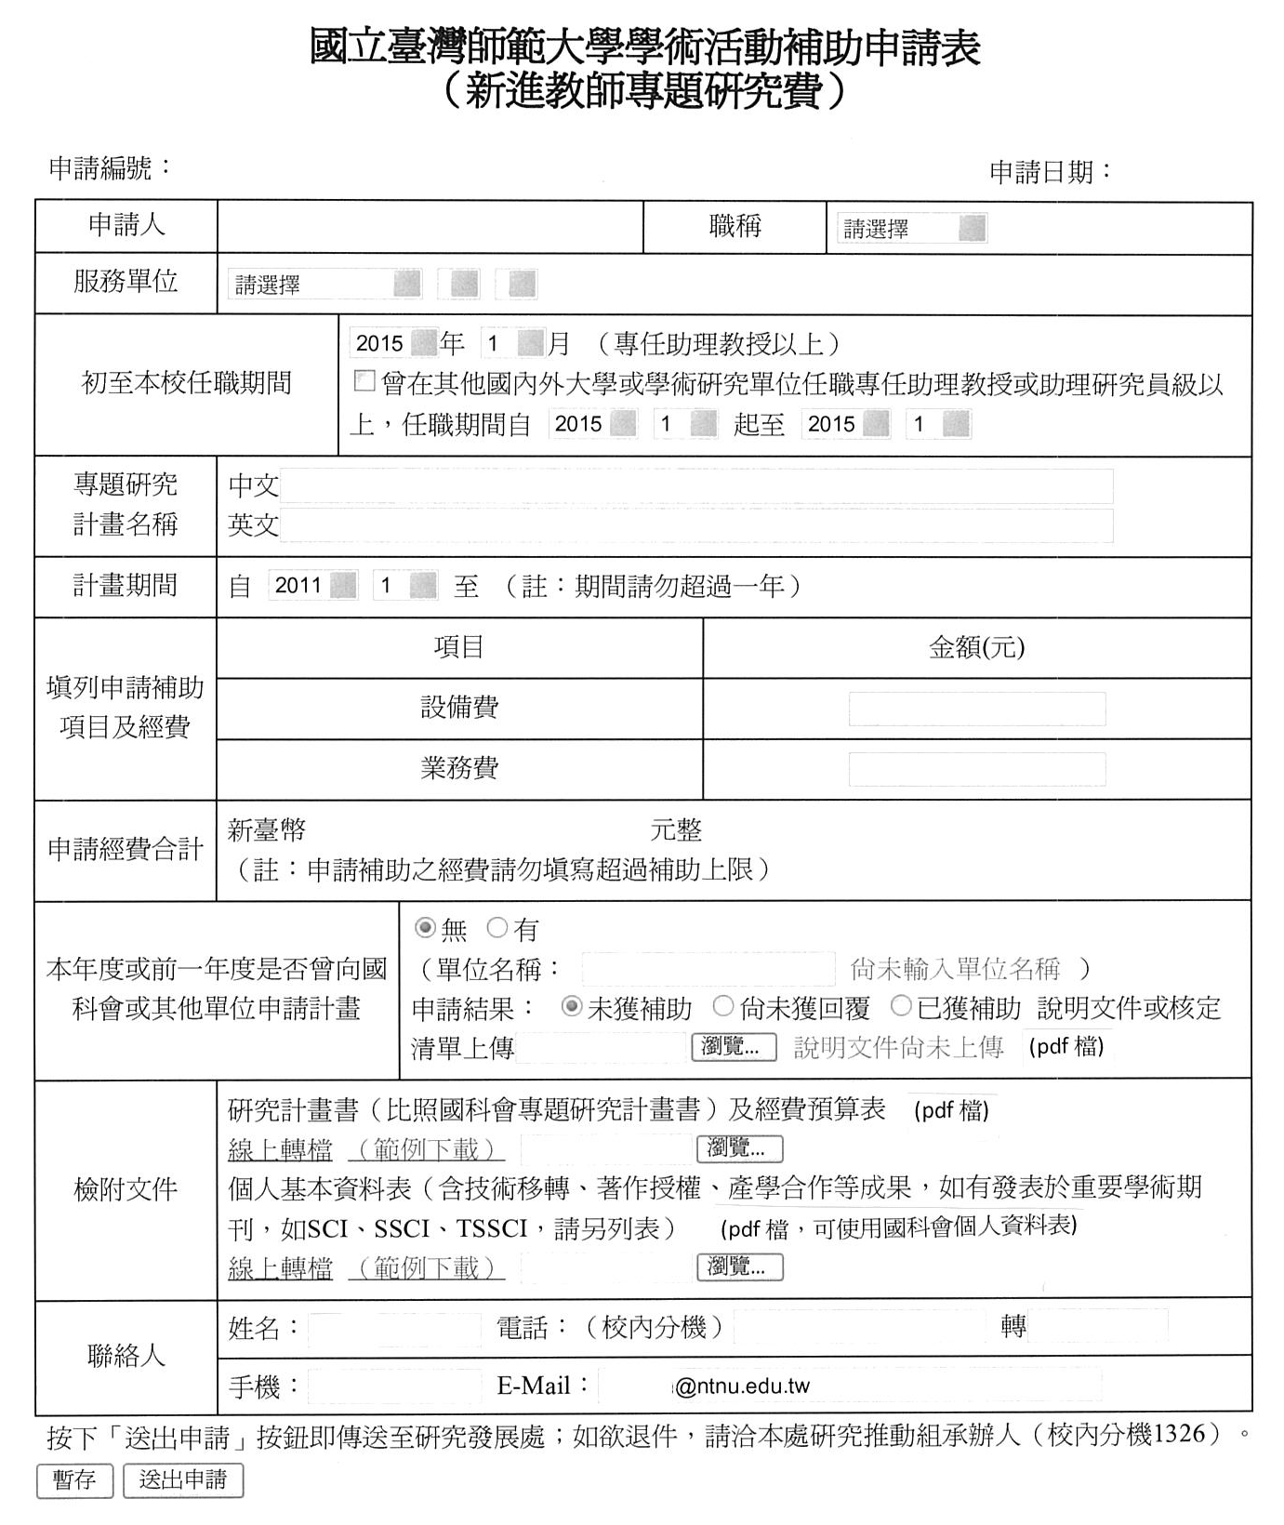

B. Convention of International Conference and Seminar (Two terms per year: Mar/Sep)
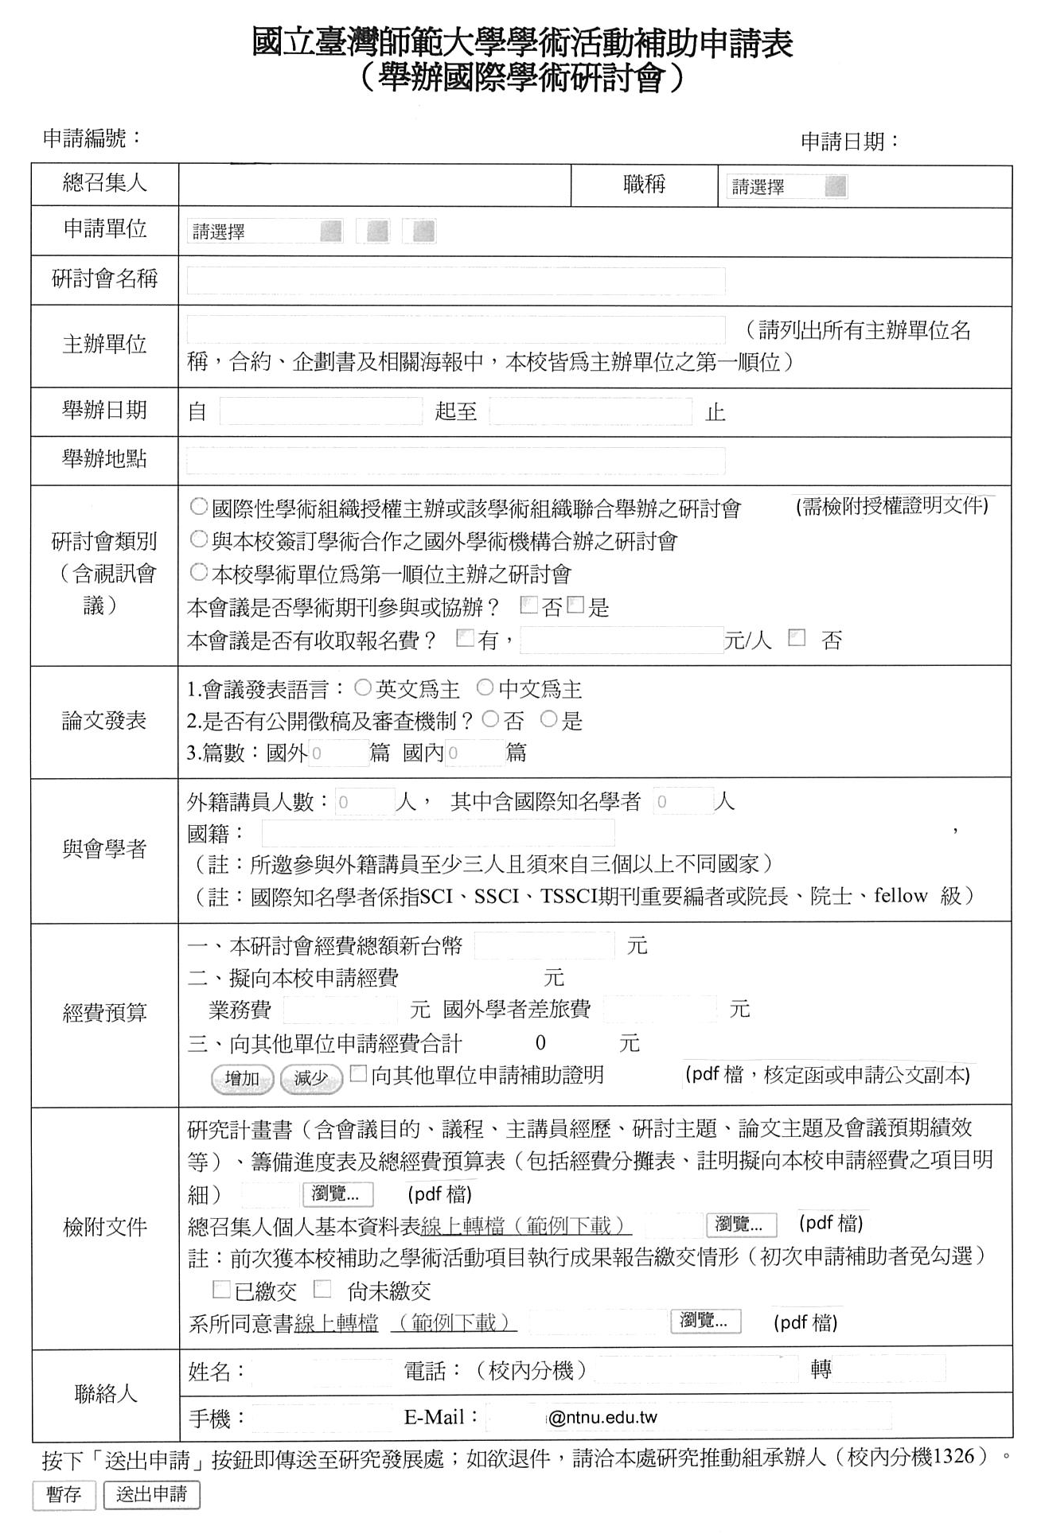

C. Arts Exhibition and Performance (Two terms per year: Mar/Sep)
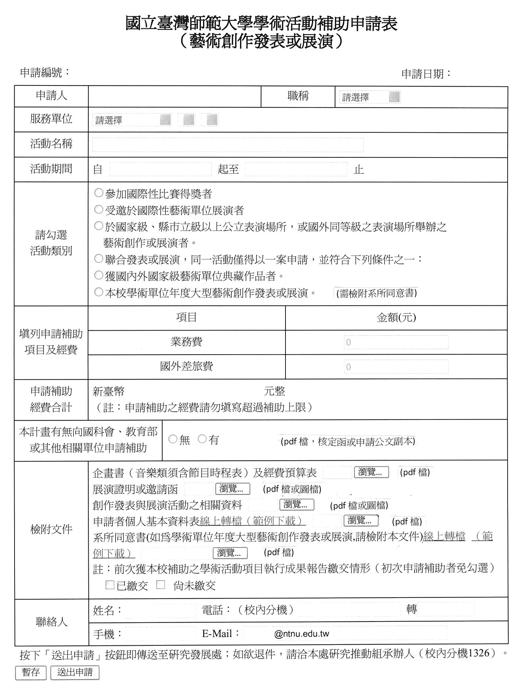

D. Academic Thesis Publication (Oct each year)
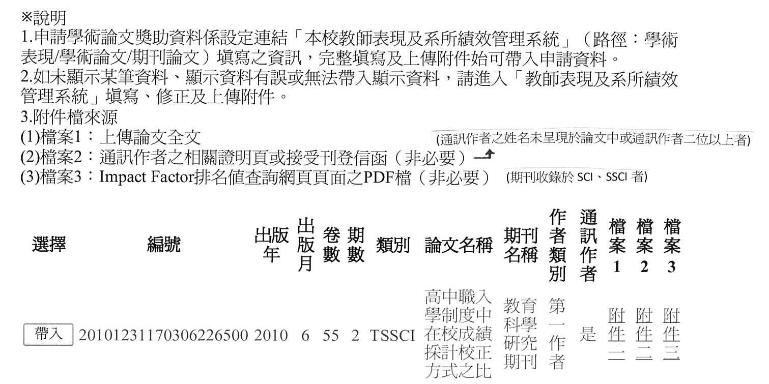

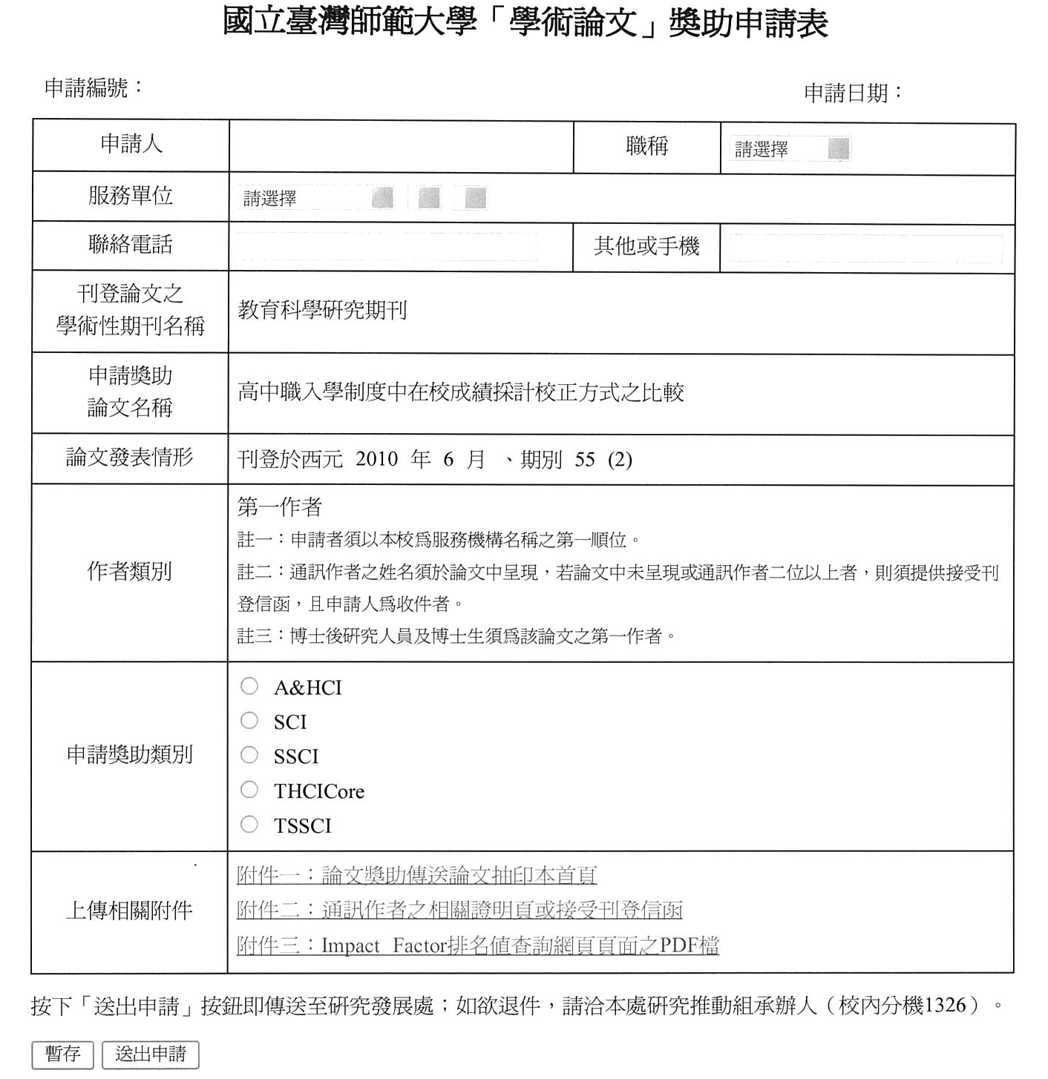
E. Academic Book Publication (Oct each year)

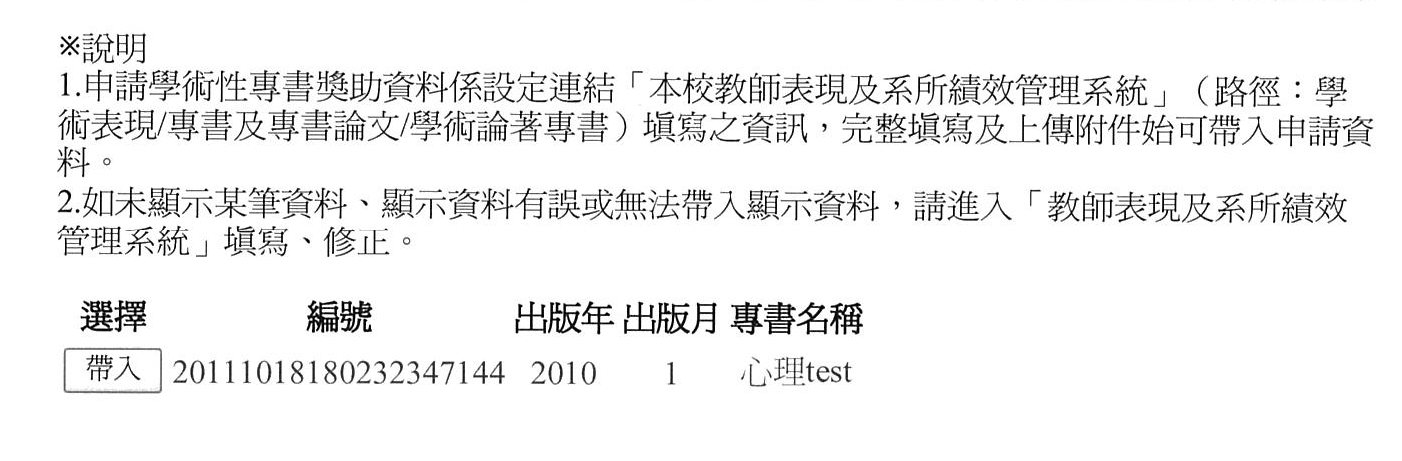
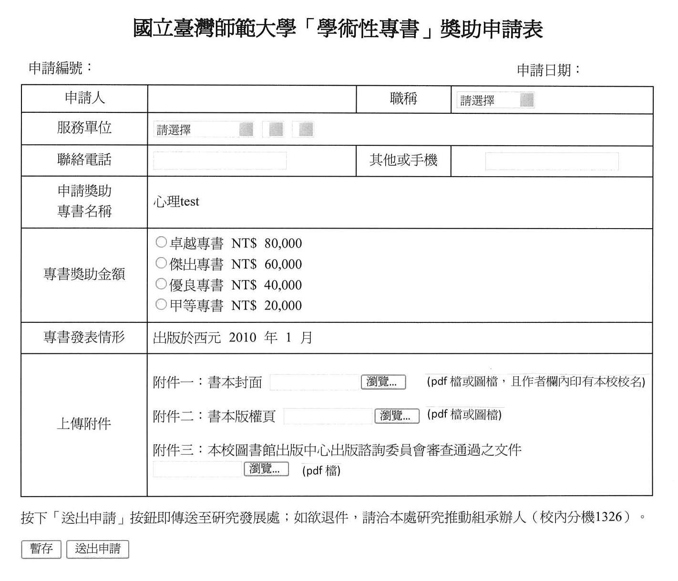

F. Page Charge for Original Thesis Publication (case-by-case)
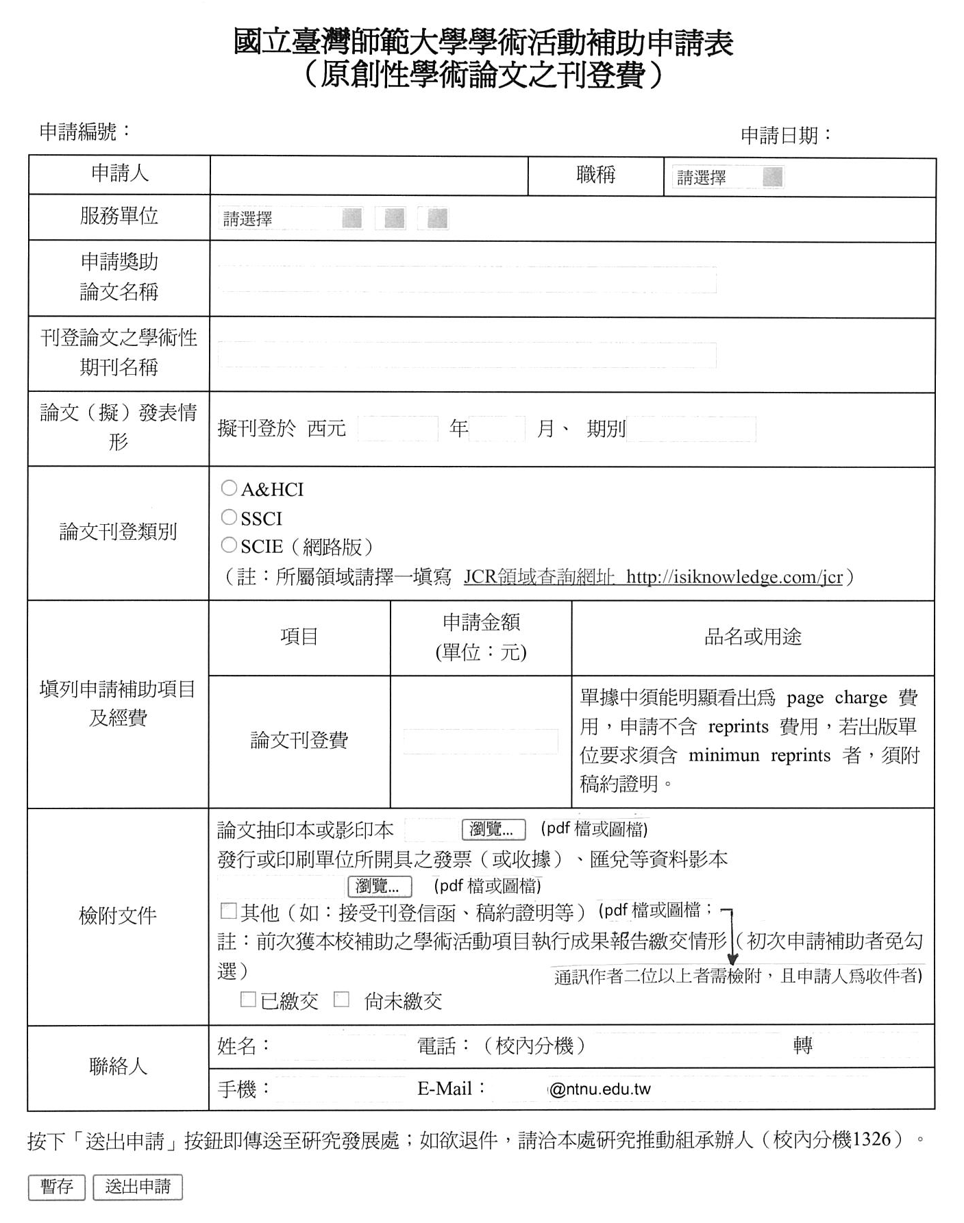

G. Overseas Thesis Publication in International Conferences (case-by-case: Five weeks prior to the conference)
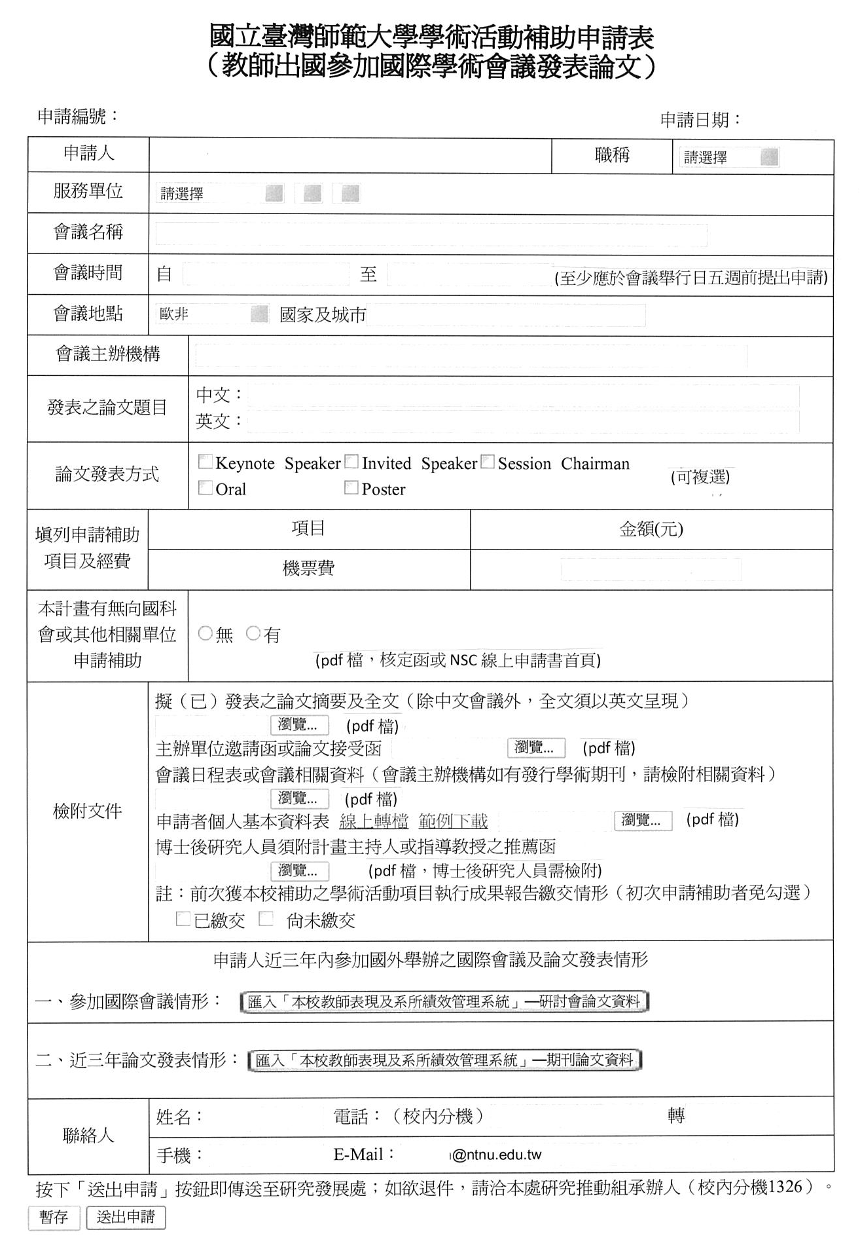

H. Improved Academic Research (Team)
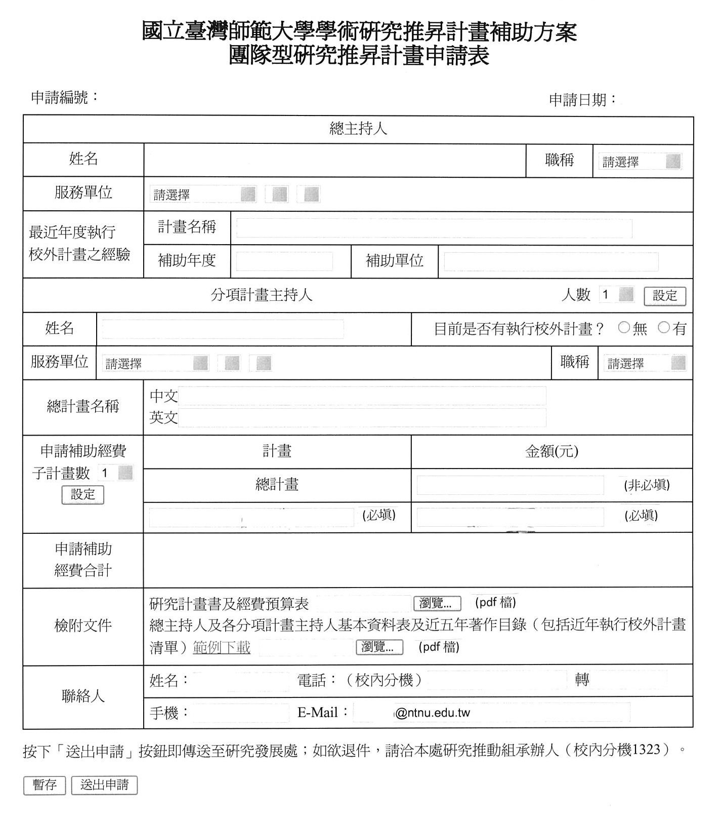

I. Improved Academic Research (Individual)
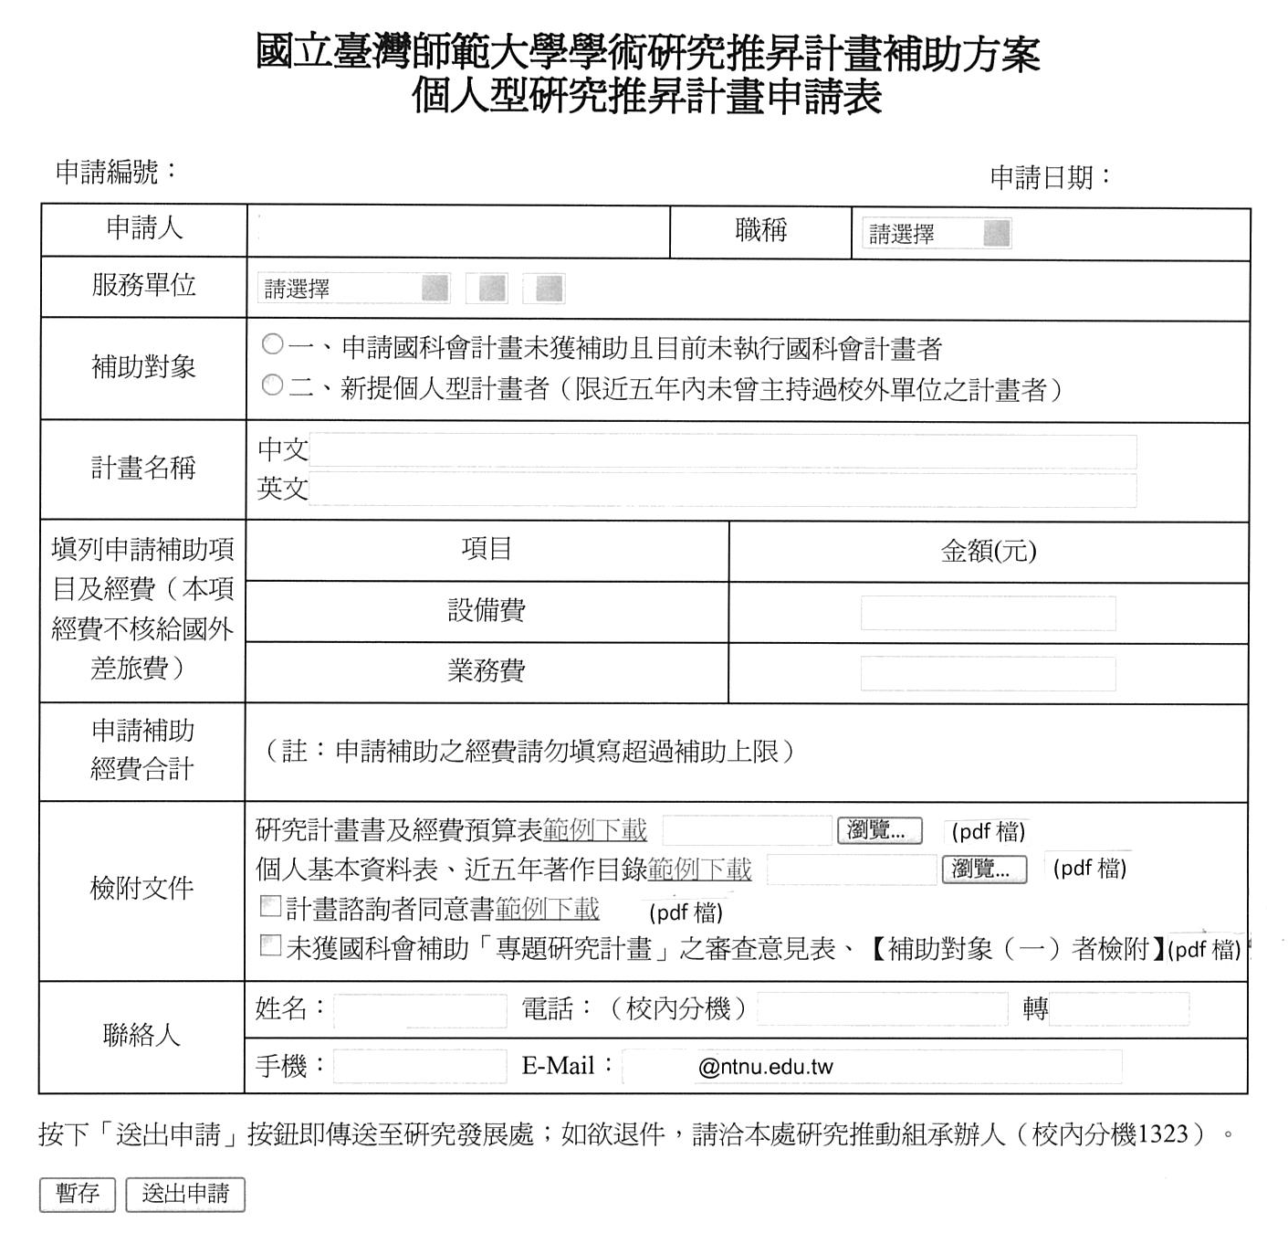

2.4 Fill in the application and upload attachments
2.4.1 Cache: incomplete applications can be saved and edited on a later date.
2.4.2 Send application: Applications can be sent once the fields have been filled and attachments uploaded.

2.5Confirming application status and printing the application form
2.5.1Confirm application status: Go to "Case List" and confirm that the status is shown as "Application sent."
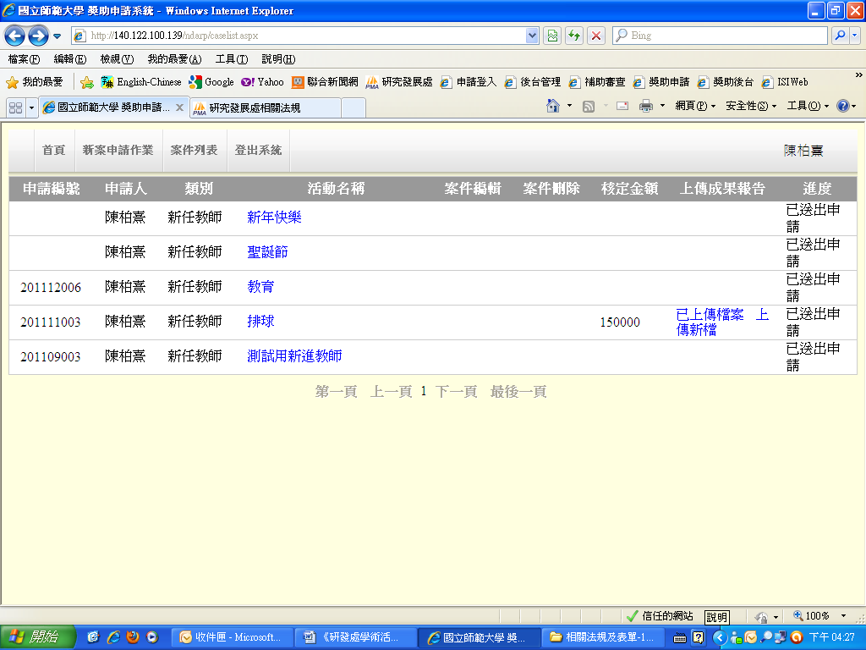

2.5.2 Print application form: Go to "Case List," click on the "Case Name" that has been sent to bring up the completed application. From the toolbar, click "File" → "Print" to print out the application form (there is no need to print attachments). Sign on the application form and deliver to the Division of Academic Research Promotion and Coordination, Research & Development Department, to complete the procedure.

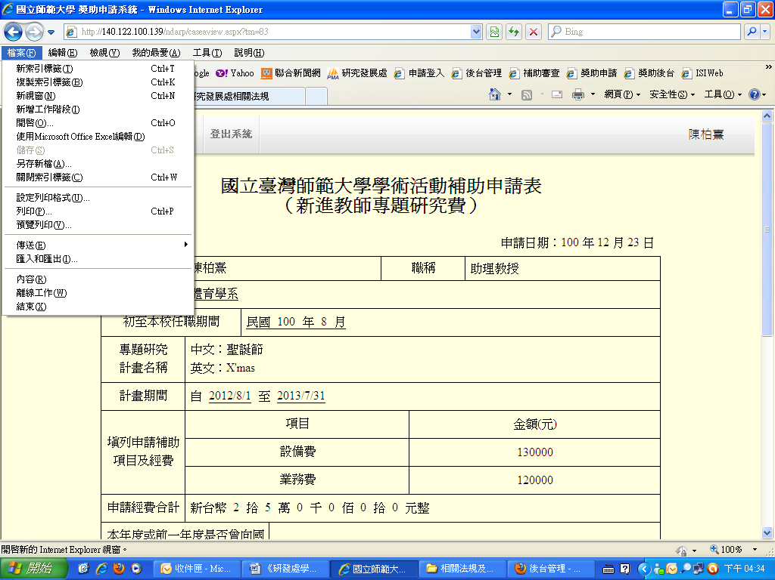

3. Case list
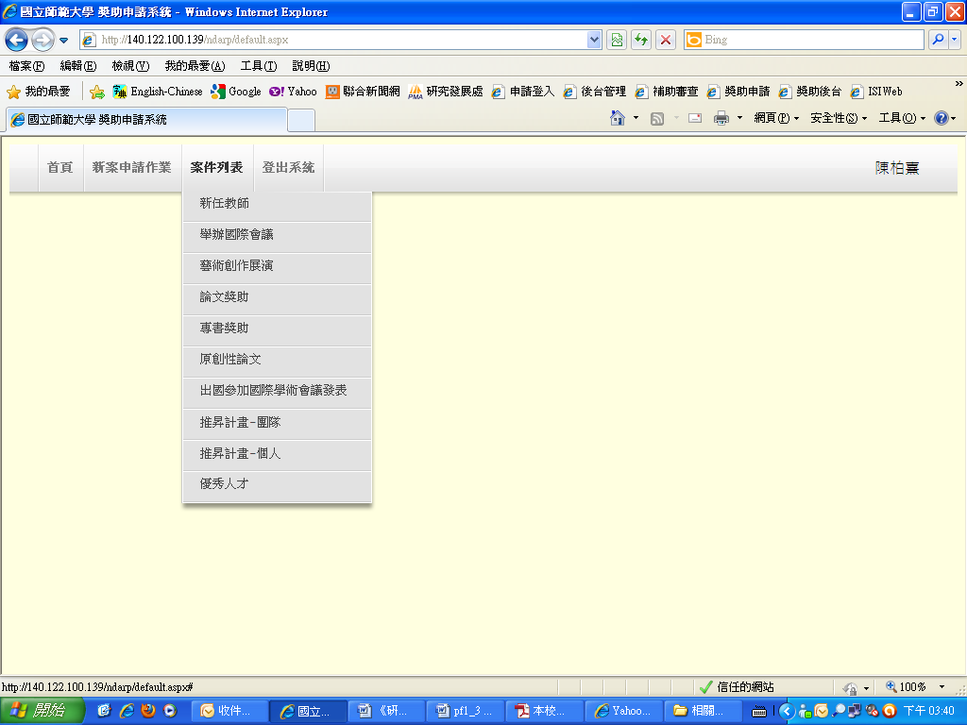
3.1 Case status (A): Shows the current status of the case (Editing/Application sent)
3.2 Edit content (B): Make changes to cached applications (cases with status shown as Editing)
3.3 Replace attachment (C): Use another attachment for the application (cases with status shown as Editing).
3.4 Upload progress report (D): Submit closure report for cases that have been approved and completed.
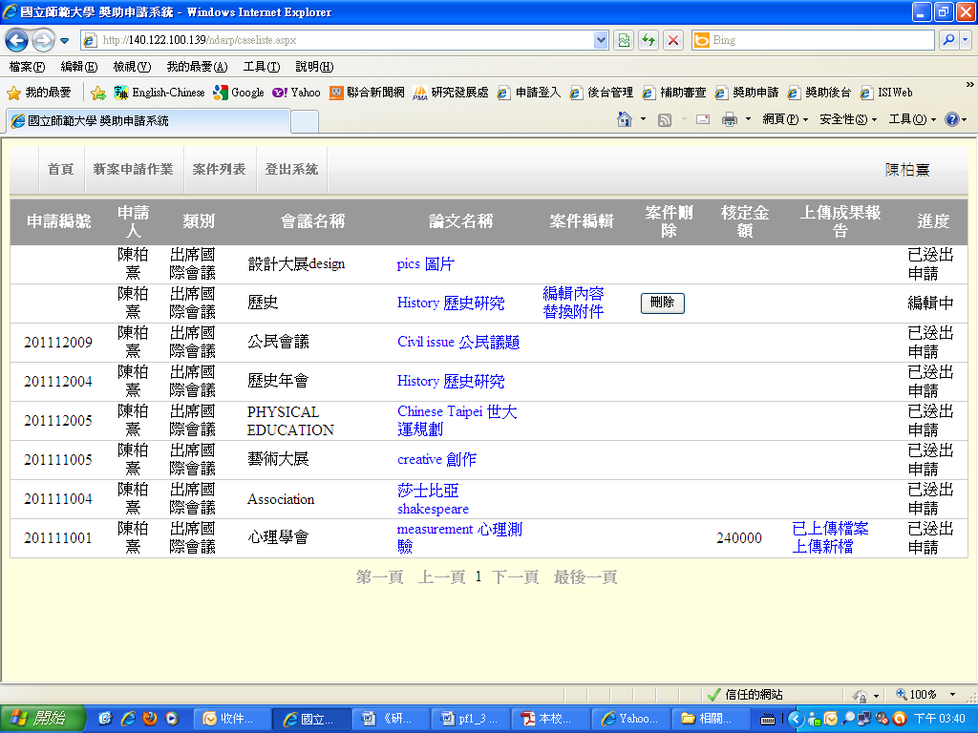
A
B, C
D
4. Log off
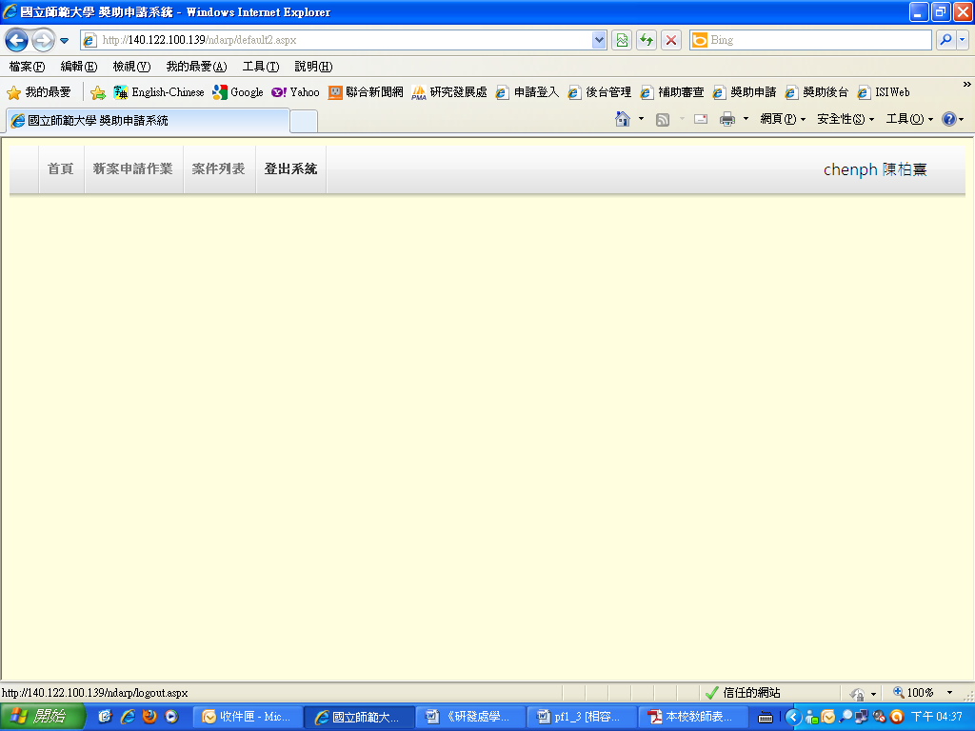

5. Contact information
Division of Academic Research Promotion and Coordination, Research & Development Department
Handling officer: Ms. Chang Chiao-Jung
TEL: 02-77341326
E-mail：changcj@ntnu.edu.tw

